FSM

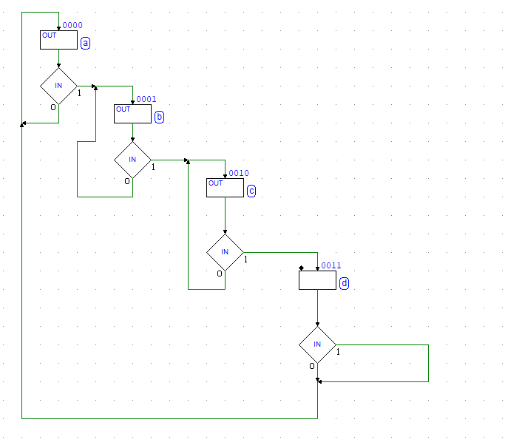

LIBRARY ieee;

USE ieee.std_logic_1164.ALL;

ENTITY AAA IS

PORT( ----------------------------------->Clock & Reset:

Ck: IN std_logic;

Reset: IN std_logic;

----------------------------------->Inputs:

i_IN: IN std_logic;

----------------------------------->Outputs:

o_OUT: OUT std_logic

-------------------------------------------

);

END AAA;

ARCHITECTURE behavioral OF AAA IS -- (Behavioral Description)

TYPE states is ( state_a,

state_b,

state_c,

state_d,

dummy_0100,

dummy_0101,

dummy_0110,

dummy_0111,

dummy_1000,

dummy_1001,

dummy_1010,

dummy_1011,

dummy_1100,

dummy_1101,

dummy_1110,

dummy_1111 );

SIGNAL State,

Next_State: states;

BEGIN

-- Next State Combinational Logic ----------------------------------

FSM: process( State, i_IN )

begin

CASE State IS

when state_a =>

if (i_IN = '1') then

Next_State <= state_b;

else

Next_State <= state_a;

end if;

when state_b =>

if (i_IN = '1') then

Next_State <= state_c;

else

Next_State <= state_b;

end if;

when state_c =>

Next_State <= state_d;

when state_d =>

Next_State <= state_a;

when OTHERS =>

Next_State <= state_d;

END case;

end process;

-- State Register --------------------------------------------------

REG: process( Ck, Reset )

begin

if (Reset = '0') then

State <= state_d;

elsif rising_edge(Ck) then

State <= Next_State;

end if;

end process;

-- Outputs Combinational Logic -----------------------------------

OUTPUTS: process( State, i_IN )

begin

-- Set output defaults:

o_OUT <= '0';

-- Set output as function of current state and input:

CASE State IS

when state_a =>

o_OUT <= '1';

when state_b =>

o_OUT <= '1';

when state_c =>

o_OUT <= '1';

when OTHERS =>

o_OUT <= '0';

END case;

end process;

END behavioral;